SOP for Federated EGA Helpdesk - Grant submitter role to FEGA user using the Helpdesk Portal

Document Owner | BioData.pt
Authors | Jorge Oliveira, Miguel Cisneiros, Jorge Silva
Version | 1.0
Document Code | FEGA-PT-Grant-Submitter-Role-1
Effective date | 07-04-2025
Origin | Adapted from Central EGA SOP V1.0

Purpose
Once you have set up your FEGA Helpdesk Portal, you can manage who becomes a submitter to deposit data to your FEGA Portugal submitter portal. If you don’t know how to get access to your FEGA Helpdesk node for the first time, please follow this SOP.

Scope
This SOP indicates the steps to follow to grant a submitter role to a FEGA user on the FEGA Portugal Submitter Portal.

Procedure
- The new member to be added to your FEGA Helpdesk Portal needs to register as an EGA user by populating the registration form.
- CEGA Helpdesk will have to verify your account. Once it has been verified by CEGA Helpdesk, proceed with step 3.
- A FEGA Helpdesk admin will login to their FEGA Helpdesk Portal (helpdesk.portugal.ega.archive.org) and go to ROLES
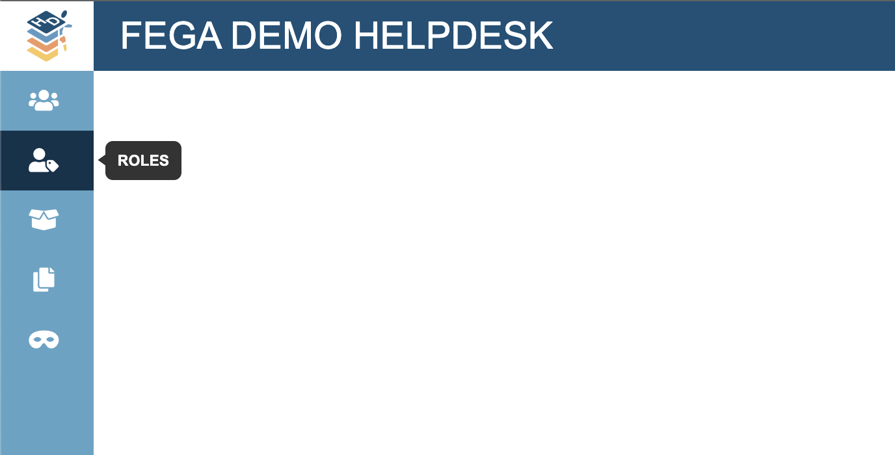
- Look for the member registered in step 1. Make sure you write the full username or email. The suggestion box is no longer implemented.
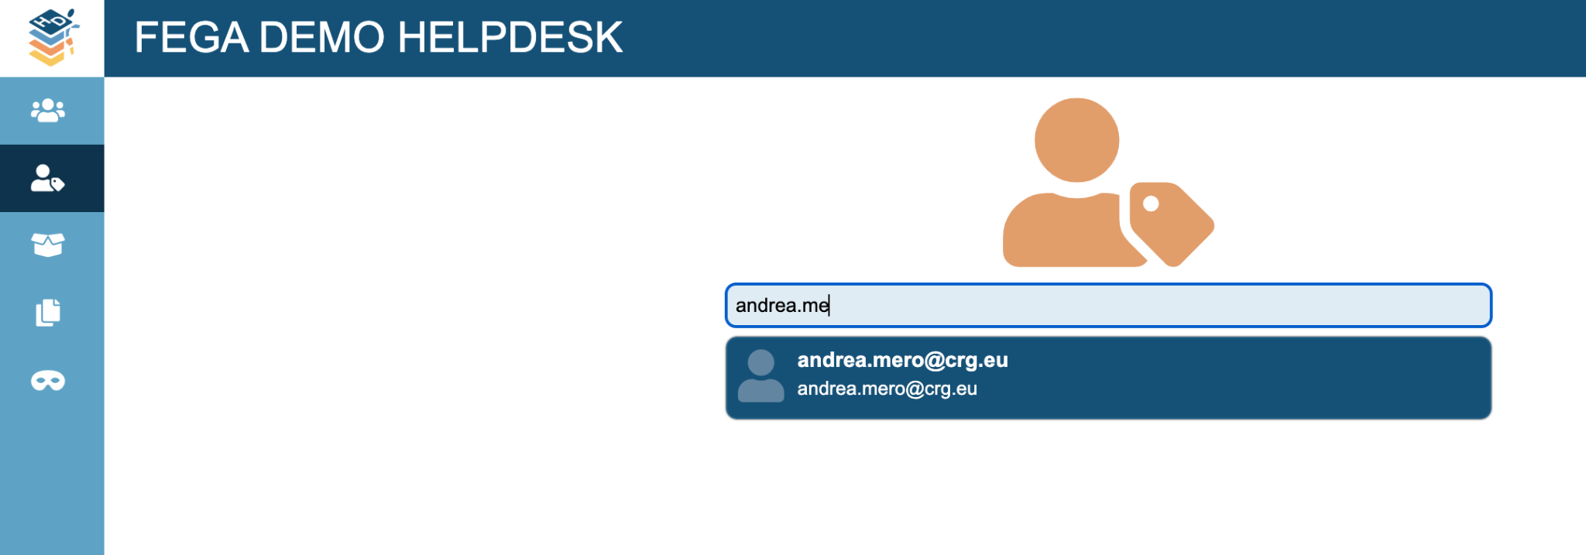
- Click on the role you want to grant to this user ({fega} submitters) and click on UPDATE ROLE
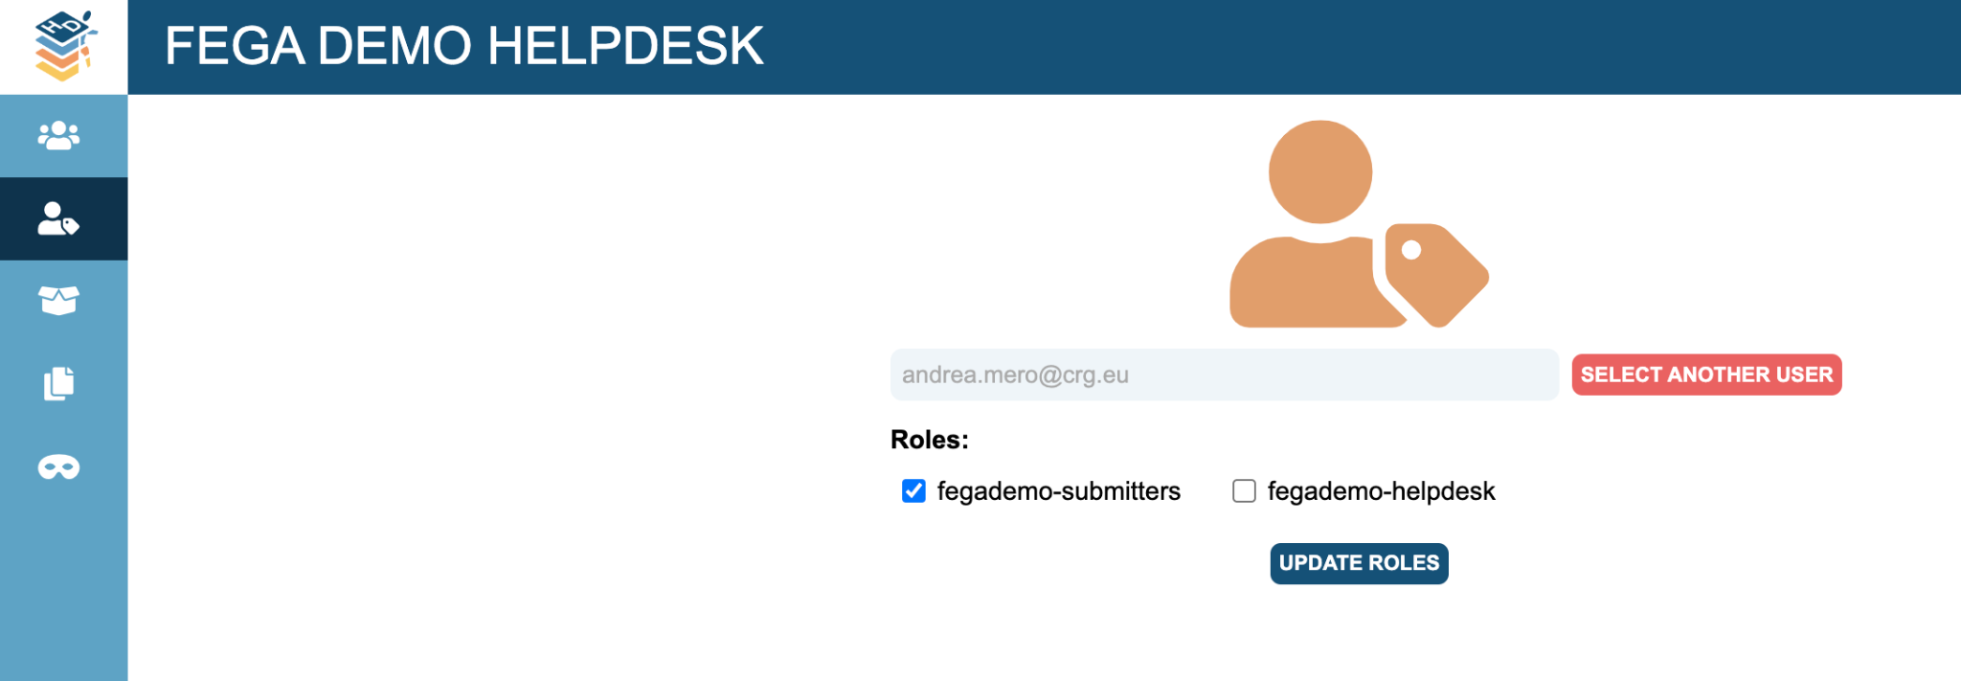
- Done!
